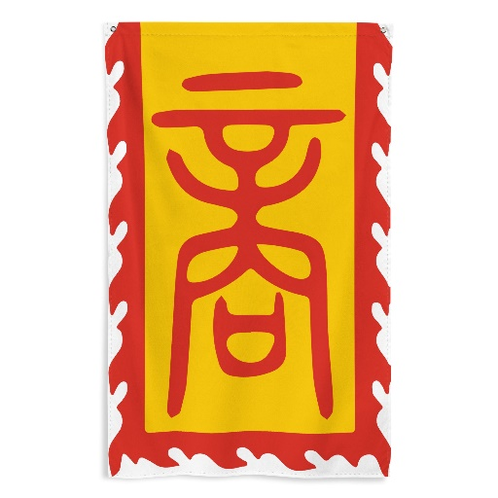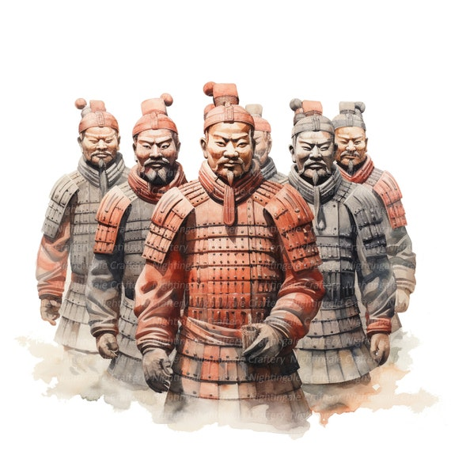

MATHS

White Rose Maths

Multiplying 2-digit numbers

Multiplying 4-digit numbers

Long division

Order of operations

Multiplying and dividing unit and non-unit fractions by integers

Multiplying and dividing fractions by fractions

Fractions of amounts

Decimals to 2 and 3 decimals places

Rounding decimals

Area, perimeter and volume

Estimating area, capacity and volume

Adding and subtracting decimals

Decimal sequences

Multiplying and dividing by 10, 100 and 1000

Percentages as fractions and decimals

Percentages of amounts

SCIENCE

Healthy lifestyles

Functions of the heart

Muscles

Classification of living things

Classification of plants

Organisms and micro-organisms

ART/DT

Chinese Terracotta Army

Chinese inventions

RSHE

Relate & Engage

Sex Education

MUSIC

Twinkle variations

COMPUTING

Online Safety

Blogging

Text Adventures

MFL

Clothing

PE

Tennis

FOREST SCHOOL

ENGLISH

Reading

Macbeth by William Shakespeare

If You Find This by Matthew Baker

Love That Dog by Sharon Creech

Description

Character profiling

Letters of advice

Persuasive writing

Poetry

Medical reports

Writing to inform

Playscripts

Newspaper articles

Role on the Wall

Word classes

Writing in role

Narrative

Spelling & Handwriting

High-frequency words

Formal handwriting practice

Word endings

Alternative spellings

Suffixes

Homophones

HISTORY

The Shang Dynasty

The Shang Kings

Life during the Shang Dynasty

GEOGRAPHY

Trading

Imports & Exports

Comparison with El Salvador

Fair Trade

RE

Christianity

Easter

Into the Dragon’s Den 2025