Rocket science
Rocket science is a job that you have to work for and have qualifications. If you’re a-levels and GCSE’s, you have to major in maths, science and physics. A rocket scientist builds stable rockets, ready for cargo, satellites, or very rarely, humans. On average, a rocket scientist earns around $115,000 dollars a year ($9583 a month).
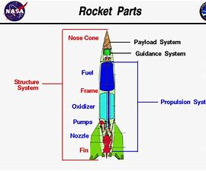
The parts of a rocket are: the nose cone (the tip of the rocket); the payload system (where the cargo or satellite is kept); the guidance system, makes the rocket go which ever direction the scientists back at the space station choose; the fuel and oxidiser, the fuel gives the rocket energy and the oxidiser takes in electrons and turns the fuel into power; the propulsion system which is the pumps, which threads the fuel through the nozzle, the fuel, the oxidiser and the nozzle; the frame is the part outside of the fuel and inside of the rocket; and the structure system is the whole rocket.
The last rocket that has been launched was in the United Kingdom in 1996 with help from NASA. This was called The Black Arrow. Prospero was a 66Kg satellite that was being launched into the sky, along with The Black Arrow.
As the rocket is launched, when it reaches the outer layer of our atmosphere and one tank of fuel has run out, the payload and the guidance system unattach and they stay in space. However, the rockets engines fall into the ocean with parachutes, ready to be collected by a team from the space centre, to be reused another time.

Click here to watch a short video about rocket science

