ENGLISH
Designing mythical characters.
Writing our own Greek myth.

Arthur and the Golden Rope.

Non-Chronological report –Ancient Greece.

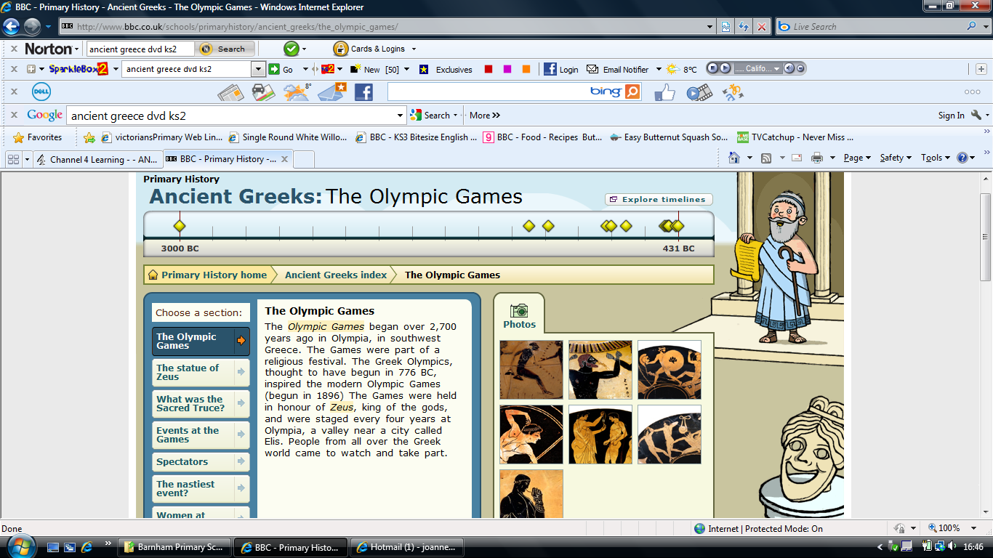
GROOVY GREEKS
MATHS
- Number and place value, multiplication and division, measure, fractions, shape, time, Roman numerals, addition and subtraction.

COMPUTING
Purple Mash:
- Simulations.
- Branching databases.

SCIENCE
Sound: What is sound? Can sound travel through different materials? Explore the relationship between distance and volume. Investigate how sounds can be different pitches and volumes.
Exploring pitch; making a straw pan pipe.

Animals including humans – health and movement: Nutrition. Balanced diet. What do animals eat. Human skeleton, animal skeletons. Skeletal muscles.

French
Instruments

ART and DESIGN TECHNOLOGY
Grayson Perry and Greek pottery
Seasonal Food

HISTORY
Who were the Ancient Greeks? Period in history.
Greek timeline of key events.
Athens and Sparta – what was life like?
Ancient Greek temples.
History of the Olympics.
Ancient Gods.
Influence of the Ancient Greeks on civilization today.

GEOGRAPHY
Modern day Greece – key geographical features.
Map work/flags.

RE
Hinduism Brahman.
Hinduism Pilgrimage.

RHE
Feelings/Anxiety/Positive and low self-esteem.

Music
West Sussex Music Service – Djembe drums

PE
Maypole dancing.
Throwing and catching
Sports day

