William Penn

Term: Summer 2024 Topic: Helpful Heroes Class: Cadbury

Week | Personal, Social and Emotional Development | Communication Language and Literacy | Phonics  (Read Write Inc.) | Mathematics | Understanding of the World | Physical Development | Expressive Arts and Design | COOL Time Activities
Week 1  Week 2  Superworm | Starting a new term.  Sharing is caring.  Taking care of animals (worms) and why they are important.  - Build a wormery. | Focus on rhyming words  Writing adjectives  Questions to Superworm  Create your own Superworm with wool and add a speech bubble (EXAD)  Purple Mash- Mini Mash  Retell story of Superworm using EXAD wool worm puppet. | Red Ditty Book writing and reading  Thinking of ways how to improve a sentence.  Consolidating and extending set 1 and set 2 sounds understanding. | Adding by counting on  Taking away by counting back  Length- Make the longest worm you can without breaking the playdough and hold it next to a ruler to measure how long they are (number recognition and measuring skills) | Bug hotel  Fact find about worms (C&L) | Woolly worms game  May Day Dance Practise | Playdough superworms  Repeating pattern wool puppet  Tagliatelle painting  Music Express | Tuff Tray=  - Cooked spaghetti chn must pick up with tweezers with dirt and magnifying glasses.  - Have positional words with a flower pot and a worm toy.  - Threading beads to make worms.  - Design a superhero  costume for a worm.  - Making worms using cheerios and spaghetti.  Small world=  - Minibeasts set up  - Re-enact super worm with playdough, rocks and small bugs  Maths=  - Create playdough worms that have eyes that they can put on and comparing lengths between their worms.  - Measuring worms with multilink.  Writing=  - Writing adjectives describing worms and having laminated words for them to read and copy.  - Writing worm as an acrostic poem.  - Finding rhyming words.
Week 3  Week 4  Week 5  Supertato | Say No to bullying  How can we face our fears? | Design a different fruit or vegetable superhero.  Design a new sidekick for Supertato.  Speech bubbles from caption for a picture from story Supertato.  Pea wanted poster  Cut up sentence and put in order | Red Ditty Book writing and reading  Thinking of ways how to improve a sentence.  Consolidating and extending set 1 and set 2 sounds understanding. | Counting to and from 20  Doubling  Evil pea has stolen a number. Which number has he stolen today? (Missing numbers in number line and superhero number sentences) | Where do vegetables come from? Farming industry, how do they grow etc. –  Healthy eating | May Day Dance celebration practice | Create human faces with vegetables- Giuseppe Arcimboldo (Computing)  Design own superhero using different vegetables/fruit  Design a vehicle that Supertato can use to travel around the supermarket  Paper plate evil peas  Watercolour painting to make a poatato  Music Express | Tuff Tray=  - Frozen carrots with faces displayed and chn must figure out ways to defrost the carrots to set them free.  - Cut out vegetables from magazine and draw on faces.  Role play=  Superhero dressing up.  Writing=  CVC cards with milk cap letters.  Design your own superhero- what is he like?  Maths=  - Frozen peas on lamniated number using tweezers on the number sentence sheets and chn must add the peas and can then smash the answer.  - Counting small potatoes using tweezers.
HALF TERM
Week 1  Week 2  Super Duper You | Morals behind the stories we read.  What makes a good friend? | A poster on ‘If you were a superhero what would your super power be?  Create you as a super hero.  What superpowers do you have already?’  Writing a book about real life super heroes e.g. my mum is my hero because…  Word Processing write on the computer: My hero is _____. (C&L) | Red Ditty Book writing and reading  Thinking of ways how to improve a sentence.  Consolidating and extending set 1 and set 2 sounds understanding. | Halving and sharing  Odds and evens | Researching ordinary heroes  What makes you, you?  Explore family trees – what makes your family different and special.  Visits from Heroes in the community – nurse, doctor, vet | Fitness Frenzy- Lesson 1 & 2 | Superhero masks  Superhero capes  Superhero scenes with chn as hero  Design a superhero gadget out of junk modelling  All about why I am a hero collage (celebration of you as an individual) | Tuff Tray=  -Design your own superhero: have a person outline with bubbles round demonstrating what they can do (eg strong or fast etc) and then they can design what they would look like. T to have a laminated version displayed and speech bubbles with the questions and pictures of what they can include (eg what does his cape look like (alongside a picture of a cape)).  - Design your own superhero mask and emblem: following on from the superhero they made the chn can use wiggly scissors, black strip paper, colouring materials, string and scissors.  Maths= super number bonds to 10: chn to write in the rest of the number bond that is displayed.  Clocks provided to demonstrate knowledge of ‘o’clock’.  Make a display board of o’clock times relating to the school day, including clock faces showing the times. Ask children to match the photos to the correct time of day by discussing and sequencing the day’s events.  Writing= Superhero writing: display a variety of well-known superheroes and cartoon superheroes with white large laminated arrows where chn can use a whiteboard pen to write the superhero’s powers. Also to have a large bubble in the middle, so that they can write which superhero they would like to be like.
Week 3  Week 4  Last Tree in the City | Being kind and helpful  Random acts of kindness  Being a “super friend” and what that means | Book talk- discuss why this would be in our Helpful Heroes topic just by looking at the front cover  (Read the book and discuss again)  What makes Edward a hero (mind map)? (adjectives)  Poster about the importance of trees  Tree poem (shared writing)  Seasonal poetry | Red Ditty Book writing and reading  Thinking of ways how to improve a sentence.  Consolidating and extending set 1 and set 2 sounds understanding. | Composing and decomposing shapes  Volume and capacity | Why are trees important?  Different types of trees  Woodland walk  How are the city and country different? (Links to C&L)  Weather changes and seasons (weather diary) | Fitness Frenzy- Lesson 3 & 4 | Finger paint trees for the four seasons  Plate gardens  Picture of city and countryside using recycled materials  Leaf rubbings | Tuff Tray=  - Fill the tray with mud and plastic and food wrappings. Chn to dig out all the rubbish.  - Fill tuff tray with pine cones, leaves, sticks, pebbles, grass and magnifying glasses for chn to do discovery play with. Also chn can make their own tress using these materials.  - chn can paint whatever they like onto a small wooden disc (the size of a coaster), having the wood as their canvas.  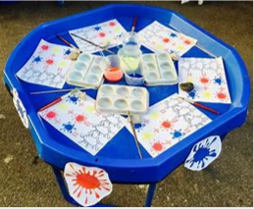  - Mixing blue and yellow to make green to paint a tree.  Maths=  - Organise all the animals that benefit from trees from the tallest to the shortest and then from the heaviest to the lightest using scales.  - Building numicon over the green landscape setting to look like buildings, then using bulldozer toy to swipe them all away.  Writing=  - Kindness tree- chn to write kind words or compliments to themselves or each other on a tag and tie it (PD) to the tree. Then at the end of the day T reads all the kind things that people have written.  - What can you do to help the environment? Chn to write all the ways they can make a difference.  - Have words desribing trees (colours, parts of a tree, texture) around tuff tray to copy on various writing media.
Week 5  Week 6  Pesky Plastic | How we can be good at home and school?  Moving on to year 1 – our anxieties or challenges.  What are we looking forward to?  What will be different? | How can I help to save the ocean? Poster  What am I? Ocean creatures  Sea acrostic poem | Red Ditty Book writing and reading  Thinking of ways how to improve a sentence.  Consolidating and extending set 1 and set 2 sounds understanding.  Assessment Week | Sorting into 2 groups  My day | Under the sea facts/habitats/animals  Why do we need to protect our oceans?  How do we protect the oceans?  Under the sea science experiments | Fitness Frenzy- Lesson 5 & 6 | Junk Modelling  Bubble Painting  Creating an ocean scene  Bubble Wrap Printing  Make a large 3D turtle | 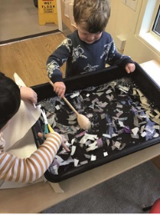  Water Tray=  - Cut strips of paper and plastic and put them in the water for children to fish out using spoons and fishing nets, to fish out the rubbish to save the sea creatures.  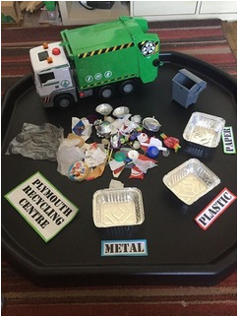  UTW=  - Organise recycling into metal, plastics and paper.  - Only have water toys in water tray that are made of plastic. Eg, plastic bottles that are turned into fish and boats.  Literacy= What am I? Have chn write the name of the sea creatures under their pictures.  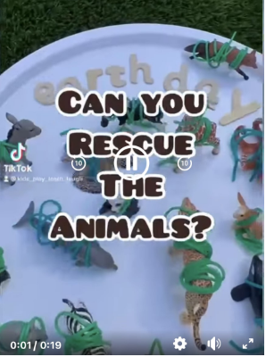  PD=  -Untangle the sea creatures.  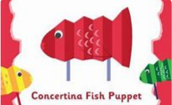  -Make concertina fish puppets using pre-cut paper and matchsticks.  - Bowling with plastic bottles.  Maths=  - Using magnetic fishing rods, fish with numbers on and plus and takeaway signs on. Have chn catch the fish to make their own number sentence.  - Build an octopus with eight using multilink.
Week 7 | Preparation for Year 1  Assessment Week
SUMMER HOLIDAYS

