Do you approve the Viking invasion?
Article of a balanced argument about the Viking invasion

The first attacks from the Vikings started in 793 AD. They landed ashore at the monastery of Lindisfarne from Scandinavia. Did you want that to happen? Did you want the Vikings invading our country? Is it a good or bad thing? Read this balanced argument to see what other people have thought about this invasion.

The Vikings made the UK a civilized place to be, they brought law, order, everyday words like war words; Knife, gun, anger and berserk. As well as casual words e.g. Window, leg, cake, law and husband. They even created the days of the week, every single one of them! They brought boats, jewellery and combs and helped the economy of Europe. The Vikings named cities ending in – ed - Thwait or Dale. If you enjoy skiing, say thank you to the Vikings because they made it more popular! They shaped Britain by bringing trades and courts where punishments were made.
However,

Vikings also had a bad side to them...
They destroyed innocent people and their there home towns and villages. The Vikings stole all the valuable objects and money and burnt down the once peaceful towns and villages. They started unnecessary violence and they used all the Saxons menials and built new houses which didn’t fit their surroundings. The Vikings were not a good reputation to younger children.
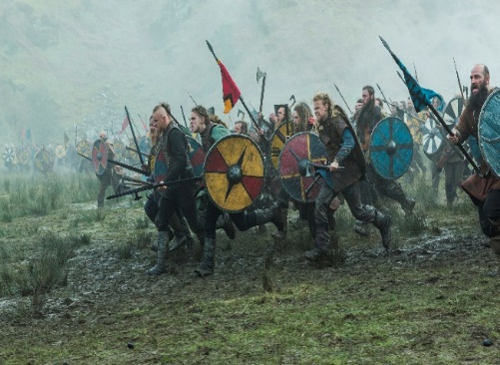
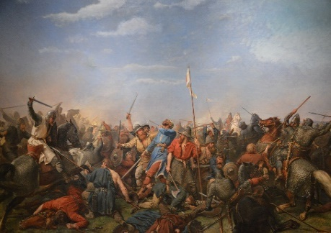
Overall, each argument is fairly balanced now and remember everyone has a different opinions. The argument has been battled and the results will be released in the next month’s paper.

