VIKING MEAT SOUP
THIS IS A VIKING SOUP WHICH WOULD HAVE BEEN EATEN REGULARLY.
INGREDIENTS:  Nettles  2 chicken thighs  Salt  enough water to cover the chicken  thyme | 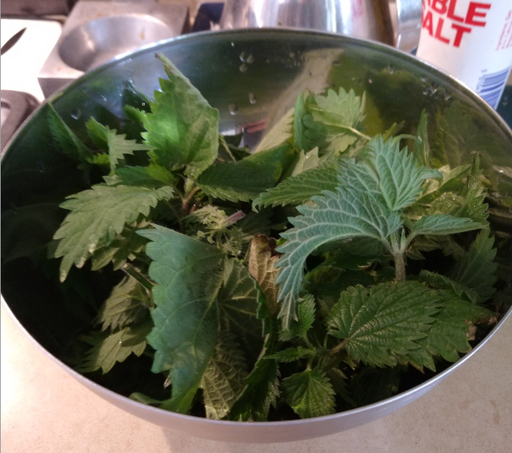 | 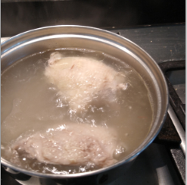 | 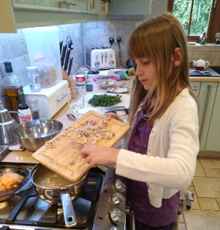
 | Put on gloves and collect the top parts of the nettles wash them and cover with a tea towel. | Get your chicken and put it in the saucepan.  Pour on water until it covers the chicken. Cook when it boils turn heat down and leave it to cook for 1 hour | Once cooked chop the chicken and put it back in the saucepan
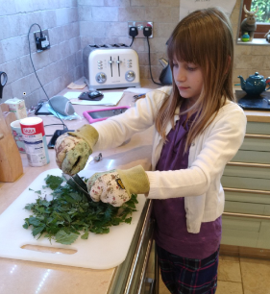 | 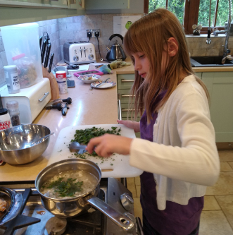 | 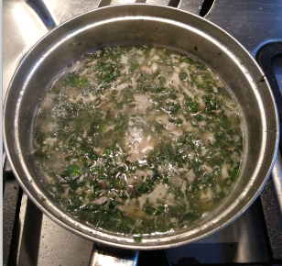 | 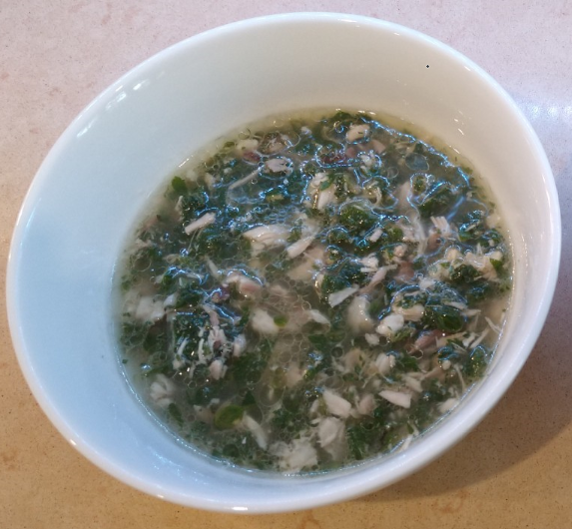
Now chop the nettles into small pieces | Then add to the pot | Mix for five minutes until the greens are cooked  Add salt to season | Then serve

