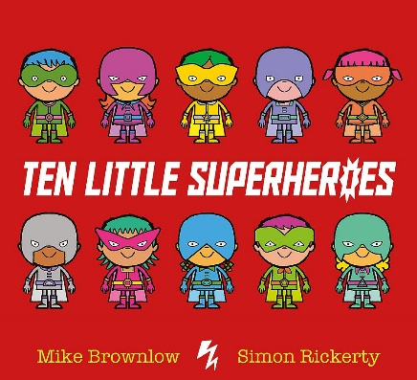
Dear Cadbury Class,

Our Recpeption topic for this term is a brand new topic… “Helpful Heroes”
As part of our new topic we were going to look at these books:
- Supertato by Sue Hendra
- Superworm by Julia Donaldson
- Snail and the Whale by Julia Donaldson
- Ten Little Superheroes by Mike Brownlow
Although we are not at school I think it will still be fun to look at these books, either online or some of you might have them at home (YouTube have some being read out loud and some are available to read online).
On the website there is a home learning activity for the first book, Supertato. If you complete any of the tasks then you can send pictures to the school office email and we can put them on the website for everyone to see!
You might also have some great superhero books at home that you can write or draw about. Have a look and see which ones you can tell me about. Your parents can email the school office any good books you have or maybe of you reading the story.
As well as the Superheroes you might read about think about some real life superheroes. You might know some, or you might have heard about some! There are lots working their superpowers at the moment. Maybe your mums or dads or brothers or sisters are superheroes. There are lots of Superheroes in the real world!
I have also uploaded some new Maths activities for you to do at home. Use resources you have at home and please don’t worry if you don’t have some of the things that they say to use.
Please carry on with practicing your reading and phonics, there is a lot of available resources online to look at, particularly on the BBC website. Numberblocks and Alphablocks are really good ones to look at.
We are all really missing you but I hope you are having a lovely time at home, keeping safe with your families and enjoying this special time we have been given.

Keep Safe Superheroes!

Ms Passfield

