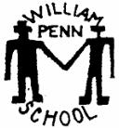

William Penn
Helping Your Child Prepare for School

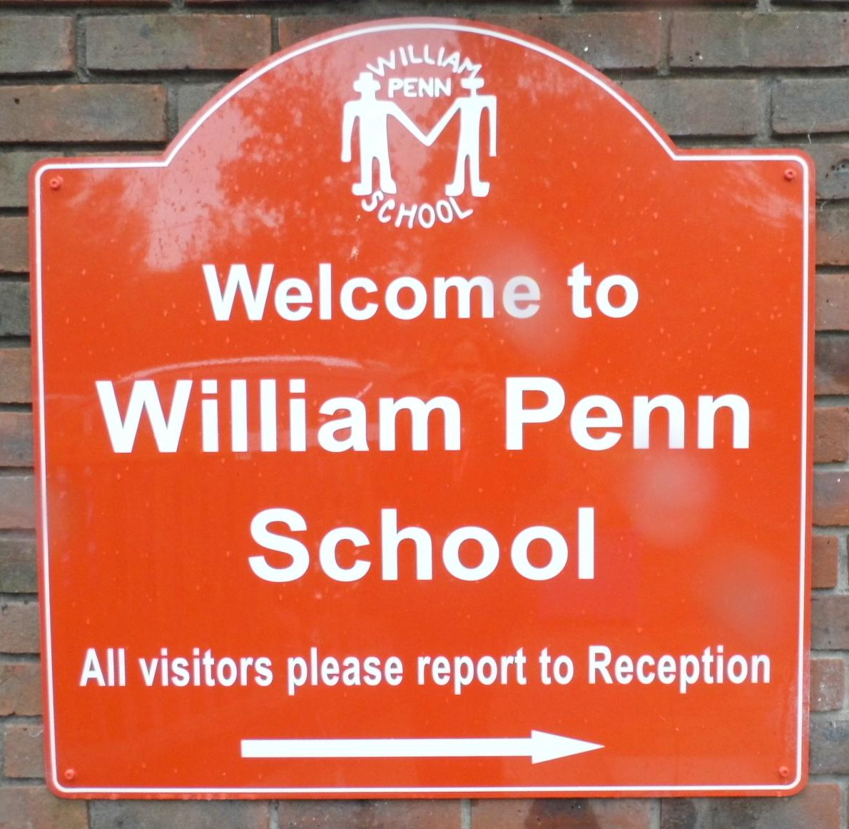
Starting school is an exciting time! It is another of the steps in your child’s life-long journey. You might be feeling a little apprehensive about your child’s first few days at school. However, the following suggestions will enable you to prepare and help your child settle down and enjoy this new adventure.

General Suggestions that Help You to Prepare

- Talk positively with your child about starting school

- Discuss your own positive memories of school with your child. Ask what they expect when starting school.

- Try to promote self-confidence in your child by using praise and encouragement to make them feel good about themselves.

- Encourage your child to be as independent as possible through daily routines such as:
- getting dressed/undressed
- cleaning teeth
- tidying up
- putting on/taking off shoes/coats
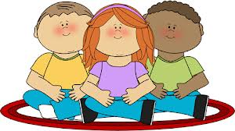
- go to the toilet and wash hands afterwards
- use a knife and fork
- blow their own nose
- sit cross legged on the carpet

- Encourage your child to take care of and respect their own things and the belongings of others.

- Give your child experience in taking turns and sharing.

- Enjoy art and craft activities such as:
- using scissors
- threading beads on a string
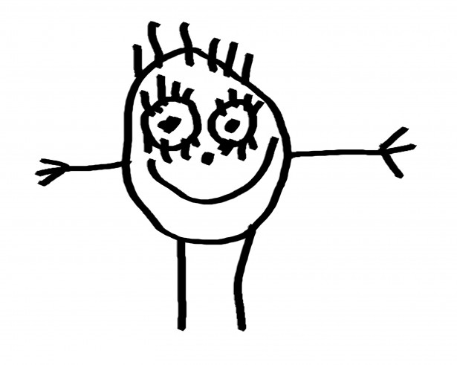
- tracing pictures
- using a pencil with confidence
- colouring in pictures
- drawing pictures of each other
- knowing the names of colours

- Play games:
- jump
- play board games
- build towers of bricks
- catch a ball thrown gently
- run with awareness of space

- Take every opportunity to talk with your child and encourage them to join in with conversation.

- Try to take time to answer your child’s questions and encourage their curiosity.

- Encourage your child to listen carefully to instructions, stories descriptions and explanations.

- Have fun with your child using action rhymes, finger rhymes and nursery rhymes.

- Help your child to recognise their written name and have a go at copying it.

Reading

- Enjoy reading with your child.

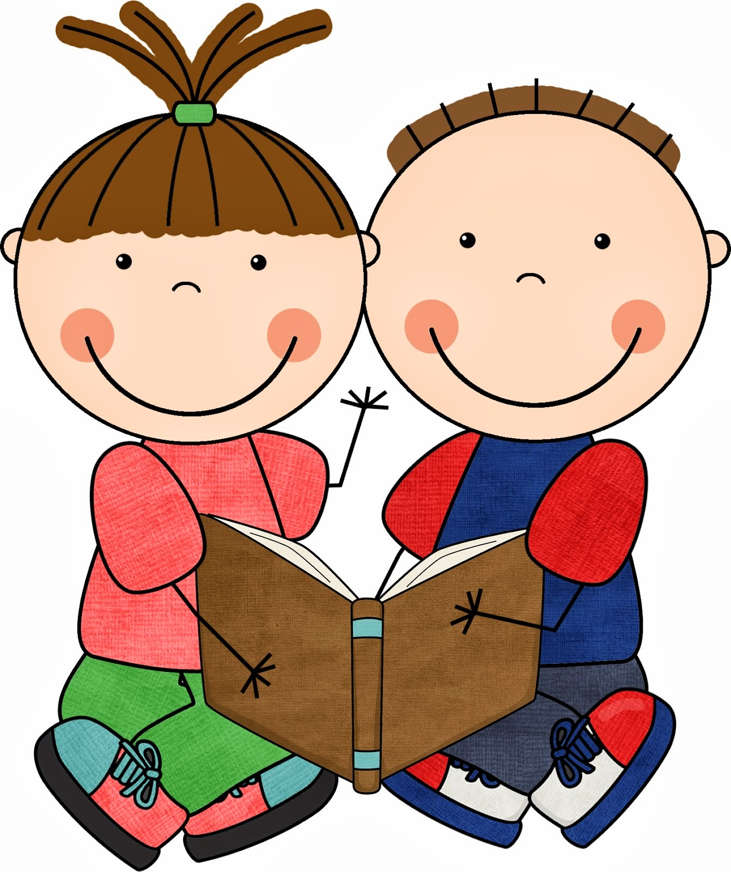
- Praise and encourage.

- Start with short reading times and then build up; stop if your child is not cooperating.

- Don’t compare your child with others; they develop and learn to read at different rates.

- Visit the library and help your child to choose books.

- Listen to audio stories during long car journeys

- Read story books and pictures books. Point to the pictures and words as you read.

- Read different types of book.

Mathematics

- Enjoy helping your child to use a little money; let them help you in the shops or a home.

- Let your child help you with baking, weighing and measuring around the house.

- Count things together eg counting socks and then counting the pairs.

- Count to 20 and back to 0

- Look out for numbers on signs and in shops.

- Talk about the numbers on the clock and begin to relate to time.

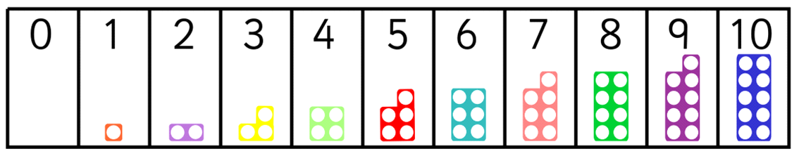

What Will Your Child Need?

- A named sports water bottle for drinking during the day – water only please.

- A named PE bag with the appropriate PE kit (all items labelled) which should be hung on their peg for the week.

- A named bag which is big enough for reading books.

- A named lunch box on those days when children are not having a hot lunch. Please label any pots and tuppawares.

The School Day

Time | Activity
8.25 – 8.35 | School gate opens (for Years 3,4,5,6 preferred)
8.35 – 8.45 | Pupil access to classrooms & Registration (all pupils)
8.45 – 9.00 | Circle Time/ Check In
9.00 – 9.15 | Assembly
9.15 – 10.00 | Teaching session 1 (normally phonics and free choice)
10.00 – 10.30 | Snack time
10.30 – 10.45 | Break
10.45 – 12.00 | Teaching session 2 (normally maths and free choice)
12.00 – 13.00 | Lunch
13.00 – 13.05 | Registration
13.05 – 14.10 | Teaching session 3 ( topic related activities and afternoon break)
14.10 – 15.15 | Teaching session 4 (topic related activities and teaching session)
15.15 – 16.15 | After-school Clubs

School Uniform List

All pupils will need one item from each box although parents may choose more.

- Grey shorts (minimum knee length)
- Grey trousers
- Grey skirt (minimum knee length)
- Grey pinafore dress (minimum knee length)
- Red and white summer dress (check or stripe and minimum knee length)
- White polo shirt (school logo optional)
- Red William Penn sweatshirt (with logo)
- Red William Penn cardigan (with logo)
- Red William Penn fleece (with logo)
- White PE shorts
- Red William Penn T-shirt (with logo)
- Black plimsolls (all year groups)
- Trainers for outdoor use (Years 3,4,5 and 6)
- Track suit for outdoor, winter wear (no hoodies)
- PE bag
- Art overall (old adult shirt, optional)
- Black school shoes (not trainers or boots)
- Grey or white socks (not sports socks)
- Grey or red tights
- No jewellery (other than plain gold/silver ear-rings studs and exceptions detailed in the Uniform Policy)
What is the Early Years Foundation Stage?

The Early Years Foundation Stage (EYFS) sets standards for the learning, development and care of children from birth to 5 years old. All schools and Ofsted-registered early years providers must follow the EYFS, including childminders, preschools, nurseries and school reception classes.
The Early Years Foundation Stage (EYFS) framework supports an integrated approach to early learning and care. It gives all professionals a set of common principles and commitments to deliver quality early education and childcare experiences to all children.

As well as being the core document for all professionals working in the foundation years, the EYFS framework gives parents confidence that regardless of where they choose for their child’s early education, they can be assured that the same statutory commitments and principles will underpin their child’s learning and development experience.
The EYFS sets out:

  - The legal welfare requirements that everyone registered to look after children must follow to keep your child safe and promote their welfare

  - The 7 areas of learning and development which guide professionals’ engagement with your child’s play and activities as they learn new skills and knowledge

  - Assessments that will tell you about your child’s progress through the EYFS

  - Expected levels that your child should reach at age 5, usually the end of the reception year; these expectations are called the “Early Learning Goals (ELGs)”

Your child will be learning skills, acquiring new knowledge and demonstrating their understanding through 7 areas of learning and development which are used to plan your child’s learning and activities.

Children should mostly develop the 3 prime areas first.
These are:

- Communication and language
- Physical development
- Personal, social and emotional development

These prime areas are those most essential for your child’s healthy development and future learning.

As children grow, the prime areas will help them to develop skills in 4 specific areas.
These are:

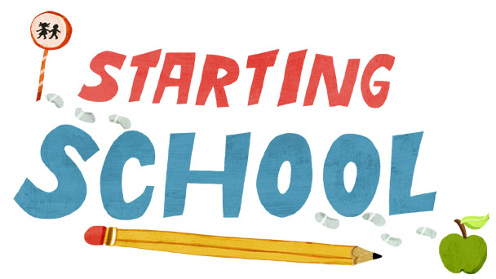
- Literacy
- Mathematics
- Understanding the world
- Expressive arts and design

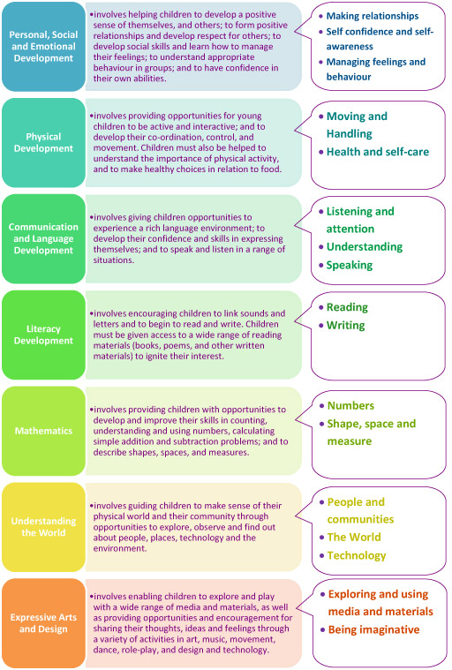
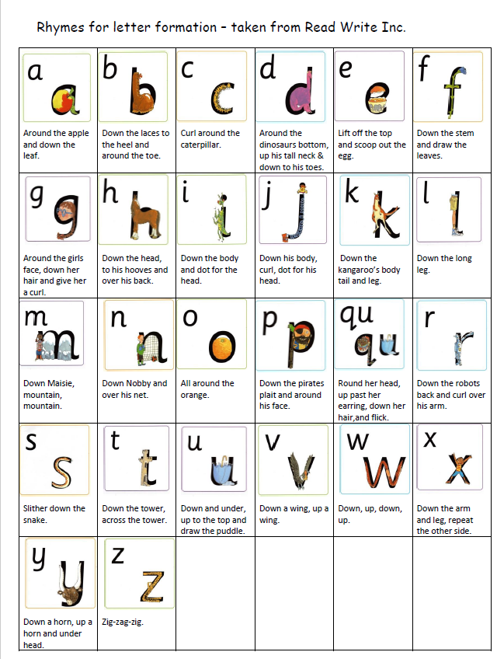

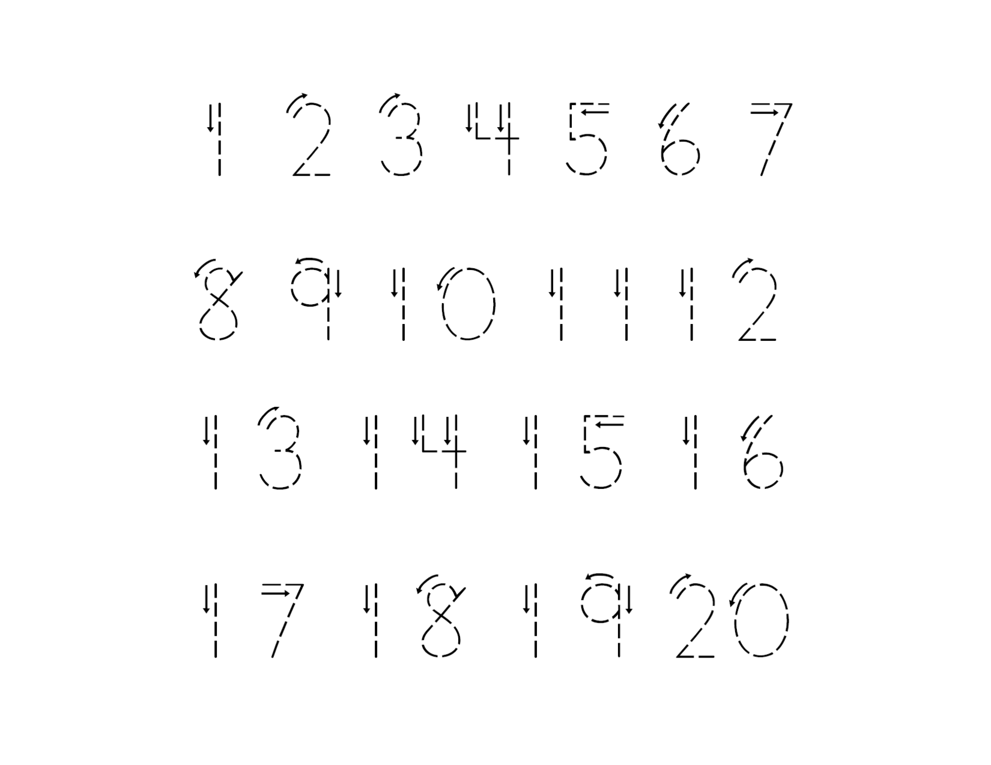



Did you know?
News from home

Did you know?
News from home
Did you know?
News from home
Did you know?
News from home

