AREA 51
Area 51 was built in 1995 and is located at Groom Lake, a dry lake bed in the centre of the Nevada Desert, 85 miles north of Las Vegas. Area 51 is a popular name for a United States Air Force base. People believe to have had sightings of UFO’s and some believe to have been abducted by aliens to be tested, then brought back down to earth. There are loads of games based on area 51 but none have an exact layout, as only a couple people have been inside the gates. It is a strict law that no planes are to be able to fly overhead of area 51. It is a private United States air force airport which only some soldiers can enter.
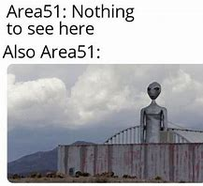
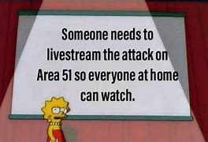
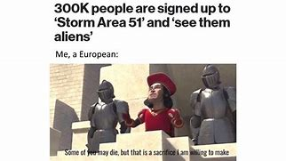
Can you imagine Netflix making a TV show about storming Area 51?
But then again, Stranger Things has happened
Why do spiders hate Area 51?
It's a no-fly zone.
What would you call a war between Area 51 and the Catholic Church?
Alien vs Predator
In honour of Area 51, what do you call too many aliens in one place???
Extra terrestrials
Dance to the ultimate area 51 song!
Let's have some alien fun, fun, fun, fun, fun! Oh we rescue aliens, we rescue the aliens
Naruto run, Naruto run to area 51, too Fast! From the area 51………..
Naruto run, Naruto run to area 51, Bullets can't hit!
Naruto run, Naruto run to area 51, too Fast!
Naruto run, Naruto run to area 51, Bullets can't hit!
Look over there! There's an alien!
There's a little alien, kept in area 51!
Help Me! I'm an alien, I'm a little alien kept in area 51

Who has been there?
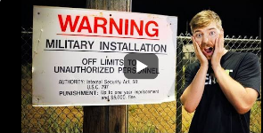
Around the 2nd of August 2019, Mr Beast went to Area 51 with a few friends and they stayed overnight there. Other youtubers also went to go to area 51.
Watch Mr Beast’s video here!

This document is made by alien studios and alien studios only. Please ask the creator Phoebe Payne if you want to use it. *Copyright.

