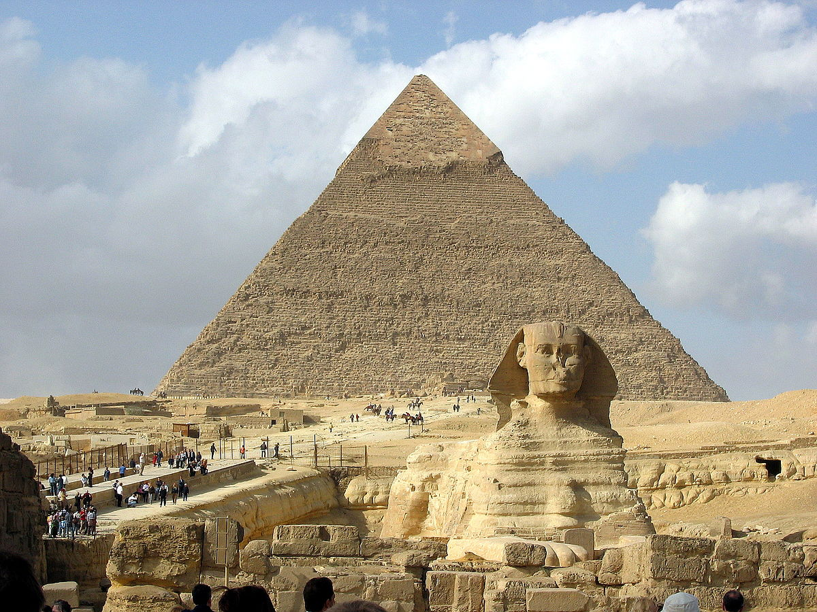
MATHS
White Rose Maths
(Multiplication and division, fractions, measurement, capacity)

EENGLISH
The King who banned the dark by Emily Haworth-Booth
Krindlekrax by Philip Ridley
(Instruction writing, letters, diaries, narrative writing, persuasive writing)

ART
Ancient Egyptian Art
Patrick Cabral

DESIGN TECHNOLOGY
Design and make a photo frame

We’re Sailing Down the Nile – Ancient Egypt

SCIENCE
Magnets: pushes and pulls, measuring forces, friction, magnetic materials, behaviour of magnets.
Springs: compression and stretching, investigating using elastic bands.

HISTORY
Ancient Egypt timeline
Horsham Museum visit - Artefacts and Mummification
Howard Carter
Tomb paintings and daily life in Ancient Egypt

GEOGRAPHY
Locating Egypt
Cairo and London – changes over time
The River Nile and the Aswan Dam

FRENCH
Animals

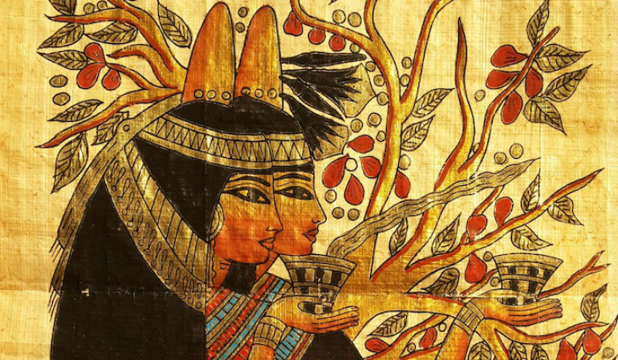

RE
Christianity – Easter

Relationships and Health Education
My Happy Mind
Healthy Relationships

PE
Tennis

COMPUTING
Purple Mash:
Writing for an audience, Logos

