How to make a Viking helmet out of a cereal box in 9 easy steps

You will need:
A large cereal box
Scissors
Pencil
Masking Tape or sticky tape
Compass for circles or something round
Paint and Paintbrushes

Steps:

1. Get your cereal box and cut out one of the large sides of the cereal box.

2. Cut of all the side parts so that the card is now flat.

3. In Length ways, cut that piece of cardboard in half.

4. Then, join those to pieces together using some masking tape or sticky tape.

5. Wrap it around your head to see whether it is too big and when you have the correct length, tape the other 2 ends together.

6. Cut one of the narrow sides off the box and stick both of the smaller ends to the front and the Back of the helmet on the inside. That should make the upper strap.

7. On any of the insides of the box, draw two horns. Cut them out and
tape them to the sides of your helmet.

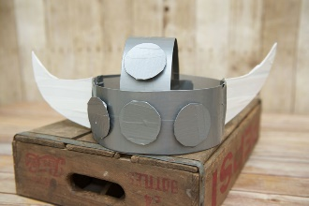
8. From the remaining pieces of the cardboard, cut out four large circles, with either a compass, glass or something round. Now, tape three of them on the round bit (5th step) and tape the 4th on to the bottom of the upper strap.

9. Finally, paint your helmet any colour you want!!!!!

If you want to make some more artefacts like a shield,
Go to https://www.kixcereal.com/kix-cereal-4-exciting-and-fun-viking-and-dragon-party-kids-crafts/

