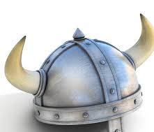
THE VIKINGS.

The Vikings came from Scandinavia and moved to Northern England in 793 AD. This is the time when they invaded –and destroyed- the Monastery of Lindisfarne. Unfortunately for them, they were defeated in 1066. This argument will tell you all about the good and bad things about a Viking invasion.

You may not believe it, but the Vikings were actually a peaceful race. They changed their ways from the Pagan belief over to Christianity. They were supportive, too. The Vikings helped shape the world that we have today. They brought us law and democracy, and they invented then built courts where punishments were decided.

However, along with Vikings building their own towns, they roamed over to other villages –armed- and burnt them to the ground. They were merciless people who did mindless vandalism, destroying everything, and everyone that dared stand in their way.

The Vikings named towns and villages, along with cities ending in –by. These included Derby and Whitby. They made new premises that were better structured than the old buildings. They also made skiing more popular. They used it as transportation.

But despite their builds, the houses and monasteries stuck out like a sore thumb. The buildings were too ugly, too big, and they did not fit in with the surroundings of Britain. Saxons did not like this because it was causing them to run out of resources.

In all honesty, I think that the Viking invasions were a good thing because they gave us words and ways of living life. And they were experts at farming, too.

