Superworm Home Learning Activities
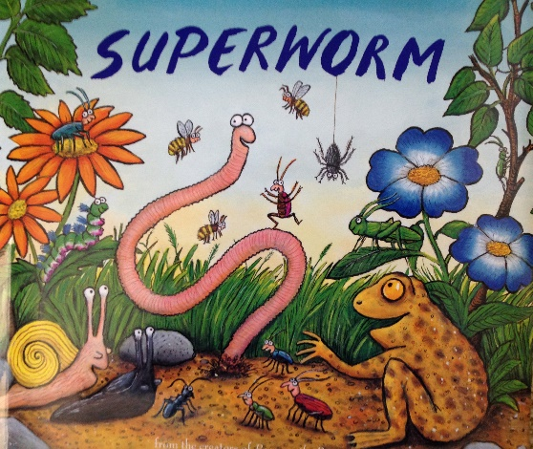
The story of Superworm is one of my favourites. You can watch the story being read online!
Julia Donaldson is also the author of Zog, The Gruffalo, the Snail and the Whale and Room on the Broom (just to name a few.)
She also uses the same man to draw the pictures to illustrate her books, Axel Scheffler.
The story is about a worm, a super worm. He is always using his worminess to rescue other animals.
It is a fantastic book that I think you will love reading, just as much as I do!
Activity Ideas:
- Using an old sock, make a superworm puppet, use things you can find around your house to make your puppet really super! You might think about some other sock animals that you can turn into super hero sock puppets.
- Write your own superhero story about a super bug, it might be one you have seen in the story or an particularly unusual insect!
- See if you can learn the superworm song, maybe you want to make some instruments to accompany you, or you might want to ask more members of your family to help you and you could all make a band. This would be a great activity to record so we could put it on the website!
- Get your adult at home to cut different lengths of string or wool. Your task is to measure how long they are and order them from smallest to largest. See if you can put it in a table or write down how long they are. This is a great maths skill that you will need in Year 1.
- Go for a bug hunt in your garden and see if you can find any super worms. Write or draw all the bugs you can find. I wonder if you will spot any unusual bugs in your gardens?
- Using an old bottle or box you could build a wormery in your garden. Lots of instructions can be found on the internet and when it is up and running it is fascinating to watch. Who knew worms were so interesting?
- Make pasta, cheerio or bead worms… you could turn them into Superworms when you are done or decorate your garden with them! Watch out though… the birds love a cheerio worm!
- Ask your parents to cook you some spaghetti so you could have some messy fun with some edible wriggly worms! Baby Edward loves this activity.. it has been a firm favourite this week!
- We also tried making some jelly worms. You need some drinking straws and some jelly. The instructions can be found on the internet but this is a great science experiment about change, and turning liquids into solids. (They looks really disgusting too!)
- You might want to make some playdough so you can roll some worms to play with, the possibilities are endless with playdough!
- There are lots of colouring and activity pages on the internet that suits Superworm
Enjoy this book! Our next book will be… The Snail and the Whale!
I can’t wait to see all your hard work on the website!

