♡Who is better, BTS or One Direction? ♡ ♡(Both) ♡
Surely we have all heard of BTS or One Direction? Well, if you haven’t where have you been? One Direction and BTS are both boy bands, but which one is better? This balanced argument describes just that.
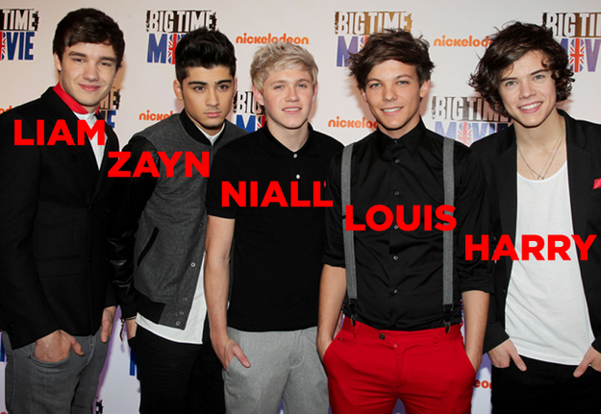
One Direction has 5 members: Harry Styles, Niall Horan, Louis Tomlinson, Liam Payne and Zayn Malik. They are all from England, except Niall, who is from Ireland. The boy band was put together on X Factor on the seventh series, where they all auditioned as a single act but didn’t get through. Unfortunately, One Direction have now broken up and are all going their separate ways .
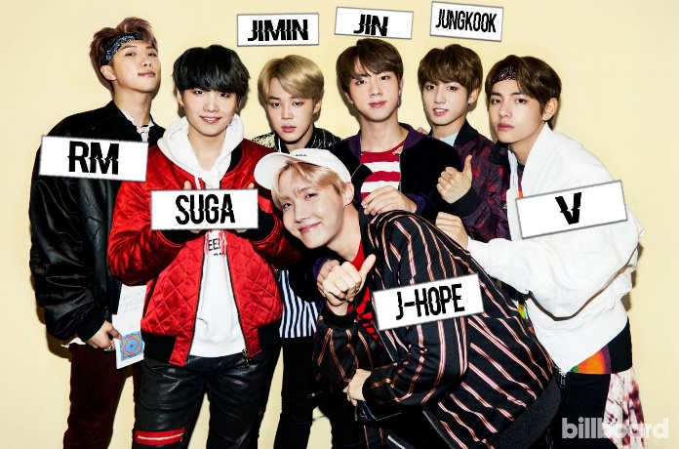
BTS stands for Bangtan Sonyeondan, which means Bulletproof Boy Scouts. They have 7 members: Jin, Suga, Jungkook, V, Jimin, J-Hope and Rap Monster (RM for short). He is the ’leader’ of the boy band. They were formed through auditions by Big Hit Entertainment but weren’t finalised until 2013. BTS are the most re tweeted artist in the World.
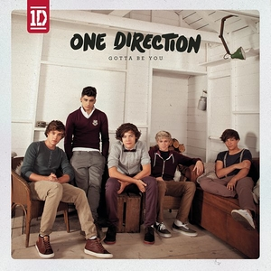
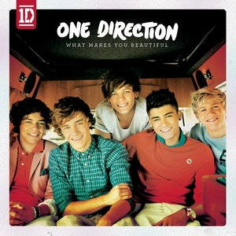
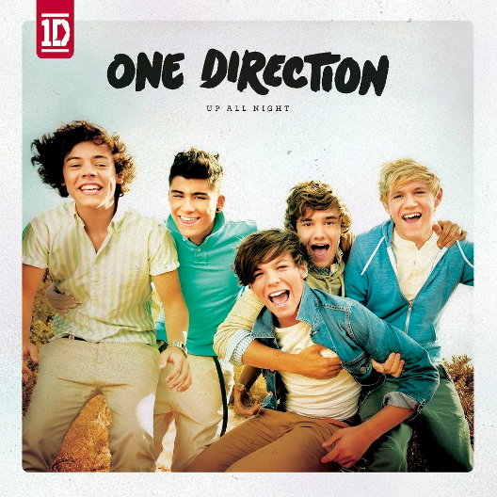
Even though One Direction broke up, they did make a lot of good songs, starting with ‘What Makes You Beautiful’ which was the 3rd fastest selling single of 2011. It was also Number 1 of the UK single charts a week after they released it. Another song ‘Gotta Be You’ was also number 3 in the charts. One Direction’s album ‘Up All Night’ was the fastest selling and the 16th biggest selling album in 2011. When they came 3rd in X Factor, they signed a 2 million pound record contract with Syco Music.

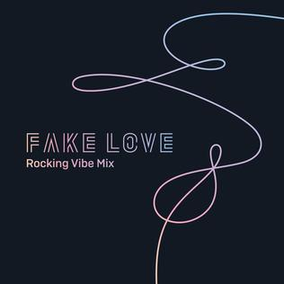
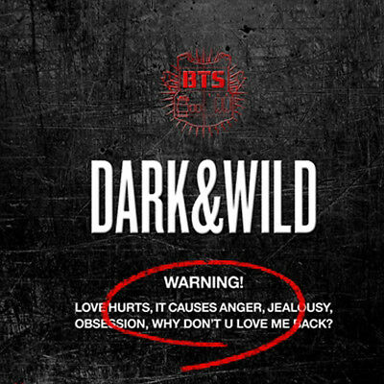
On the other hand, BTS have also been very successful with their music. They have released 22 singles within 6 years and won over 53 awards. BTS’s first album was called ‘Dark and Wild’. They have sold over 7 million albums worldwide. The boy band donated 7 tons of rice to a charity in 2016, a lot of money to poor families and Suga also donated $19000 worth of beef to orphans.

In Conclusion, I don’t want to put my own opinion because I want to stay loyal to both boy bands! However, a lot of people have heard of One Direction, whilst not as many have heard of BTS. I personally like One Direction songs more as they are more catchy and easier to sing along to (because all their lyrics are English). On the other hand, BTS have donated a lot of things to charity so I am proud to be in their army for that! Both boy bands are amazing though and I definitely recommend being in the BTS Army and becoming a Directioner! ♡

Listen to History by One Direction here: ♡

History - One Direction (Lyrics) - YouTube

Listen to Fake Love by BTS here: ♡

BTS (방탄소년단) - Fake Love (Easy Lyrics) – YouTube
