Spring Term 2025 - Cadbury Class- EYFS/ Reception

Awesome Animals

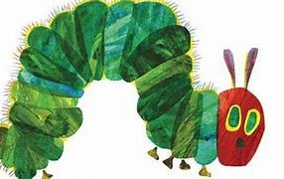

***Mathematics***

**Mastery Number**

Subitising

Counting, ordinality and cardinality

Composition

Comparison

Pattern – White Rose

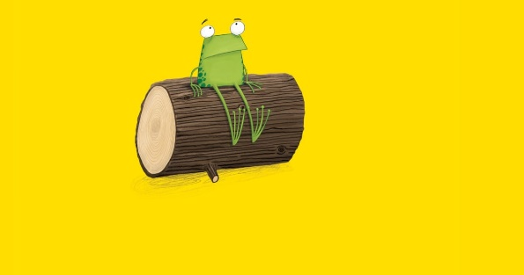

***Literacy***

The Very Hungry Caterpillar by Eric Carle

Shopping list for our hungry caterpillar

Story Map

Life cycle of a caterpillar

Days of the week writing

Daisy Eat Your Peas by Kes Gray

What are our favourite vegetables? Pictogram

Why is it important to eat healthily?

Record and label what mum offers to Daisy in the story

We are going on a bear hunt

by Michael Rosen

Story sequencing

Adjectives

Caption writing

Story writing

***Phonetical Understating***

Read Write Inc.

Set 1 revision

CVC (consonant-vowel-consonant) and multiple sound word blending.

Holding sentences and writing them with finger spaces between words.

Using red words (words you cannot sound out).

Red ditty

Oi Frog! by Kes Grey and Jim Field

Rhyming word sentences

Caption Cards

Typing sentences

Creating a class rhyming book

Handa’s Surprise by Eileen Browne

Finger puppets to retell story

Create a story sack

Letter to Handa

Shopping List

Harry and the Bucketful of Dinosaurs

To write non-fiction labels and captions

Develop verbs

instructions for how to look after a baby dinosaur?

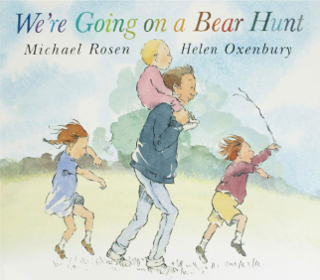

***Physical development***

Gross Motor Skill Development

Tennis by Horsham Sports

Provision: climbing frame, large building bricks for moving, den building kits, pirate ships.

Fine Motor Skill Development

Writing using the tripod grip, for holding a pencil.

Regularly using a range of small tools, such as paintbrushes and scissors.

Enhancements provided to develop fine motor skills.

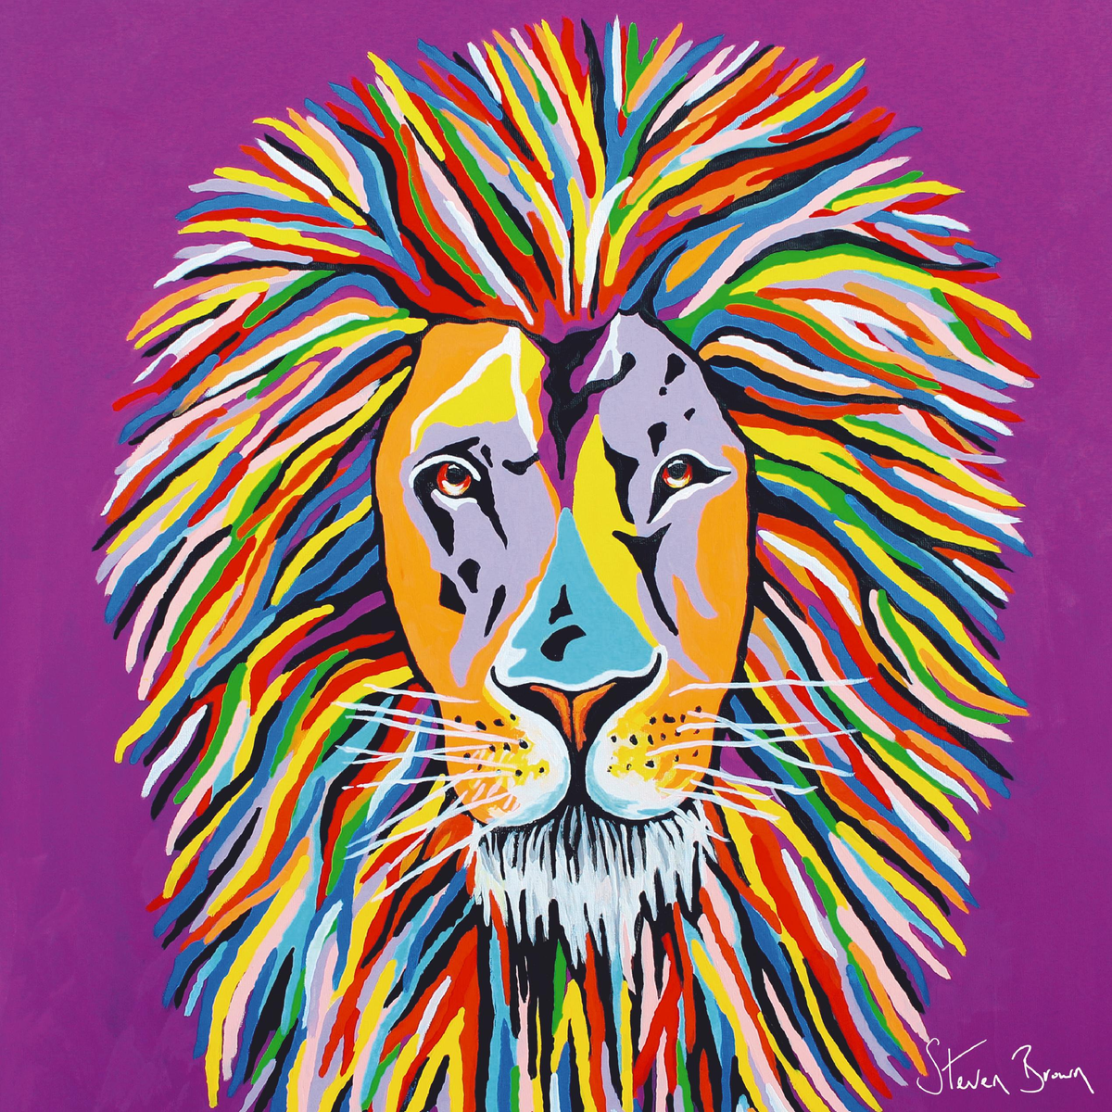

***Expressive Arts and Design***

Artist Focus: Steven Brown

Art Technique Focus: Painting

Design:

Paper chain caterpillars

Making binoculars

Fork painting bears

Frog painting (colour mixing)

Paint program on computers

Paper plate frogs

Fruit painting

Fruit observational drawing

Music Express

Musician Focus – Carnival of the Animals – Camille Saint-Saens

***Understanding the World***

What animals live in Africa?

What’s it like in other countries?

Life cycle of a Frog and Caterpillar.

Different animal environments.

Frog spawn.

Who is Mary Anning?

How can we find out more

About dinosaurs?

*Celebrations and Easter*

Religions: Hinduism,

Christianity

Chinese New Year.

The life of Jesus.

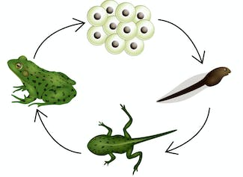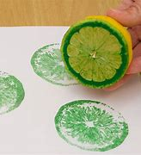 

***Personal, social and emotional development***

New beginnings- New Year’s resolutions.

Learning how to work in a group considering others

Playing and learning cooperatively.

**My happy mind – appreciate**

Gratitude frame

Appreciation

Relate – Good friends

***Communication and Language***

Welcome back to school.

Working as a team.

Class jobs.

Talking about our feelings.

Show and Tell (on Fridays).

Daily check in (restorative practice).

Circle time.

Sit and engage in story time

Why is listening important?