Here are some extra English activities you can do but please feel free to carry on using the topic writing activities.
Year 1 | Monday 15th June | BBC bitesize writing the days of the week.  https://www.bbc.co.uk/bitesize/articles/zm9hscw  Geography  Can you make your own pirate treasure map?  Can you include a key to describe what is on your map?
 | Tuesday 16th June | BBC Bitesize Book Club: Cake by Sue Kendra and Paul Linnet  https://www.bbc.co.uk/bitesize/articles/z7f2xyc  Art  Can you make your own pirate?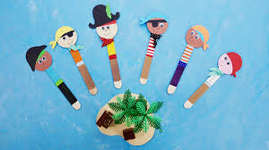
 | Wednesday 17th June | BBC Bitesize using full stops and capital letters and joining words  https://www.bbc.co.uk/bitesize/articles/zmqtnrd  Art  Can you design your own pirate flag?
 | Thursday 18th June | BBC Bitesize Attac of the demon Dinner Ladies  https://www.bbc.co.uk/bitesize/articles/z627mfr  Music  Can you watch some pirate songs on you tube and sing a long?  When I was one..  https://www.youtube.com/watch?v=x7MgOk6ZdlQ  Silly pirate song.. (Jack  Hartmann)  https://www.youtube.com/watch?v=cBcrVzY4hDE  A pirate went to see  https://www.youtube.com/watch?v=YOA3he2Gv4M
 | Friday 19th June | BBC Bitesize Science Habitats  https://www.bbc.co.uk/bitesize/articles/zjnw7nb  Art  Can you make a Paper Plate Crab?  