Here are some English, Maths and Topic activities you can do at home. We are looking forward to seeing the work you complete.
Monday | English  Look through the powerpoint of the Titanic on the website.  Can you write some sentences about:  What is the Titanic? Where did it set sail from? How big was the Titanic? What did people say about it?  Maths  Properties of 2D shapes.  https://www.bbc.co.uk/bitesize/articles/zq6p7yc  Art  Look at the picture of Van Gogh’s seascape painting and try and copy it.  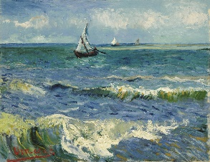
Tuesday | English  Watch the video about the Titanic.  https://www.bbc.co.uk/bitesize/topics/z8mpfg8/articles/zkg9dxs  Can you write out facts about what life was like on board the Titanic.  What was it like for 1st,2nd and 3rd class passengers?  Maths  Properties of 3D shapes  https://www.bbc.co.uk/bitesize/articles/zp2tjsg  History  Look at the powerpoint about Grace Darling.  Who is she? What is she famous for? Can you draw a picture of Grace Darling and write some sentences about her.
Wednesday | English  What happened to the Titanic? What did it hit? Why was not everyone saved?  Can you write some sentences to explain what happened to the Titanic.  Maths  Solving problems with height and length.  https://www.bbc.co.uk/bitesize/articles/zdfq4xs  History  Can you write a newspaper report of the events of what Grace Darling did that stormy night?  Key questions: What was the weather like? Who rowed the boat? What was Grace’s job on the boat?
Thursday | English  Write sentences about what happened when the Titanic hit the iceberg. What happened to the Titanic? Why was not everyone saved? Who was allowed in the lifeboats first?  Maths  Comparing Mass  https://www.bbc.co.uk/bitesize/articles/zpgtjsg  R.E  Read the powerpoint story Jonah and the Whale. Can you draw a picture and write a caption to explain what is happening in your picture?
Friday | English  Can you complete this reading comprehension?  https://www.bbc.co.uk/bitesize/articles/z942kty  Maths  Measuring mass in grams  https://www.bbc.co.uk/bitesize/articles/zcdrsk7  Geography  How can we stop pollution? (Litter in bins, walk instead of car, recycling)  Can you create a pollution poster to inform others about Pollution?

