My pony Merrylegs.

Merrylegs is my pony, she is an amazing 13.3hand sports horse. Merrylegs is a brilliant PC pony and can put her hoof to anything. She is a loving mare always willing to leap over a jump when you are riding. My lovely angel shines at shows and is a forward going superstar.

Me and Merrylegs, ridden work.

When I first saw Merrylegs when my mum brought her out of the trailer, I loved her at first sight. When I rode her the next day everything went really well and she was much larger than my last pony who was 11.2hands and if you look at the first paragraph then you will see that it’s a difference. When I rode her out of the sand school on the road, she was really excited and I began to think she wasn’t the right horse for me and we were thinking we should send her back… I’m glad we didn’t!

The next day when I jumped her she was really fast over them and I wasn’t sure I liked it much. Luckily my riding teacher came to the yard and helped me jump 80cm on her! Now I was super confident and wanted to keep her again. Since then I have jumped over 80 and was 5cm away from jumping 1m! That means I was jumping 95cm on her already! I was sooo happy and by then we were loaning her now. Now I am very confident with her and guess what? WE OWN MERRYLEGS!!!!!!!!!!!! I was sooo happy and I made a cake to celebrate.

Positives about Merrylegs

- She is an amazing PC (pony club) pony.
- She can jump up to 1m 10
- She is a loving mare
- She looks after you
- She looks forward to see you
- She is responsive and clever

Negatives about Merrylegs:

- NONE!!!!!!!!
- Hang on…
- She is EXTRIENMLY FAST – according to my sister, Phaedra.

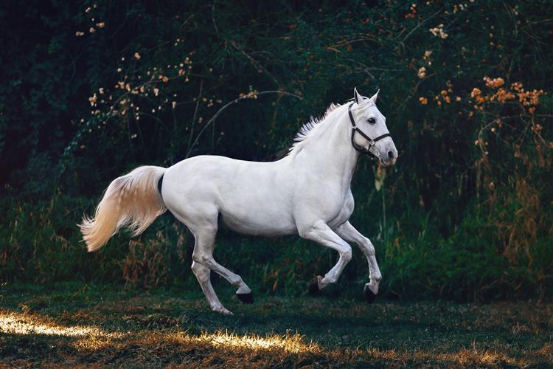

Things I want to achieve on Merrylegs

- Go to competitions on her and pony club camp.

- Aim to jump up to 1m10
- Go to the gallops
- Gallop along a beach at low tide
- Go to a pony race, professionally (possibly)
- Go on a peaceful hack, only Merrylegs and I.
