Summer Term 2024

Cadbury Class- EYFS/ Reception

Helpful Heroes

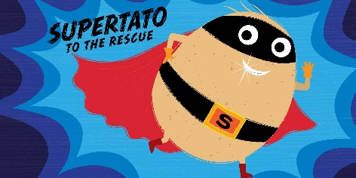

***Literacy***

Superworm by Julia Donaldson

Focus on rhyming words

Writing adjectives

Questions to Superworm

Create your own Superworm with wool and add a speech bubble

Supertato by Paul Linnet

Design a new sidekick for Supertato.

Speech bubbles from caption for a picture from story Supertato.

Evil Pea wanted poster

Cut up sentence and put in order

Super Doper You by Sophie Henn

If you were a superhero what would your super power be?

Create you as a super hero.

What superpowers do you have already?

Real life super hero writing e.g. my mum is my hero because…

Word Processing write on the

computer: My hero is _____. (C&L)

***Phonetical Understating***

Read Write Inc.

Get Writing! Red and Green Ditty Books + Handwriting.

Set 2- ay ee igh ow (as in blow) oo (as in zoo) oo (as in look) ar or air ir ou (as in out) oy

Holding sentences and writing them with finger spaces between words.

Using red words (words you cannot sound out).

Weekly spelling test on Friday

Pesky Plastics by Leticia Colon De Mejias

How can I help to save the ocean? Poster

What am I? Ocean creatures

Sea acrostic poem

The Last Tree in the City

by Peter Carnavas

Book talk- discuss why this would be in our Helpful Heroes topic just by looking at the front cover

(Read the book and discuss again)

What makes Edward a hero (mind map)? (adjectives)

Poster about the importance of trees

Tree-dwelling animal fact files

Seasonal poetry

***Mathematics***

Numeral recognition

Numeral writing

Adding by counting on

Taking away by counting back

Length

Missing numbers in number line

Counting to and from 20

Doubling

Halving and sharing

Odds and evens

Composing and decomposing shapes

Volume and capacity

Sorting into 2 groups

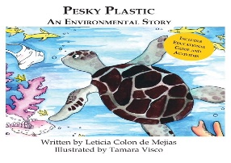

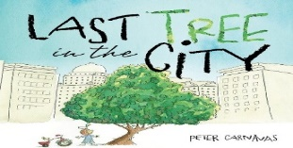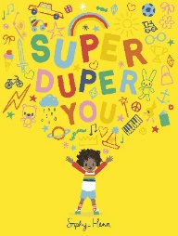

***Physical development***

Gross Motor Skill Development

Fitness Frenzy activities to develop coordination, balance.

May Day dancing rehearsals for negation of space and implementing energetic movements.

Fine Motor Skill Development

Writing using the tripod grip, for holding a pencil.

Regularly using a range of small tools, such as paintbrushes and scissors.

Everyday allotted time to develop fine motor skills.

***Understanding the World***

Bug Hotel

Where do vegetables come from? Farming industry, how do they grow etc.

Healthy eating

Researching ordinary heroes

What makes you, you?

Explore family trees – what makes your family different and special.

Visits from Heroes in the community – nurse, doctor, vet

Weather changes and seasons

Why are trees important?

Different types of trees

Under the sea facts/habitats/animals

Under the sea science experiments

Discovery RE

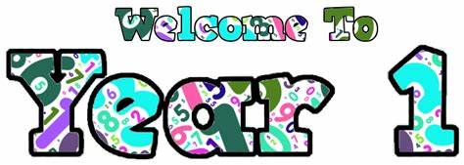

***Expressive Arts and Design***

Playdough superworms

Design a superhero

Costume for a worm

Paper worm puppet

Spaghetti painting

Design own superhero using different vegetables/fruit

Design a vehicle that Supertato can use to travel around the supermarket

Paper plate evil peas

Superhero masks

Superhero scenes with children as hero

Junk model superhero and vehicle

Finger paint trees for the four seasons

Andy Goldsworthy inspired outdoor art

Natural resource instruments

Plate gardens

Fallen leaf pictures

Picture of city and countryside using recycled materials

Leaf rubbings

Junk Modelling

Bubble Painting

Creating an ocean scene

Bubble Wrap Printing

Make a large 3D turtle

Music Express

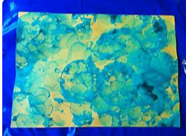

***Communication and Language***

Welcome back to school

Working as a team

Being a good friend

Show and Tell

Daily Check Ins (Restorative Practice)

Circle Time

Talking about change

Talking about new challenges.

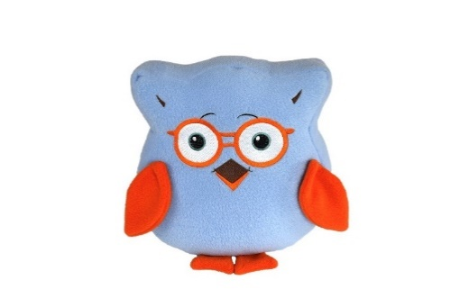

Bertie the Owl

***Personal, social and emotional development***

Starting a new term

Sharing is caring

Morals behind the stories we read

What makes a good friend

Say no to bullying, how we can face our fears.

It’s good to be me

Being part of a team

Being kind and helpful

Being a “super” friend

How we can be good at home and school.

Moving on to year 1

How we have changed since we started in Cadbury?

What are we looking forward to about year 1?

What are we looking forward to learning about?

What have we enjoyed about Cadbury class?