WARHAMMER 40,000: THE GREAT tyrannical war
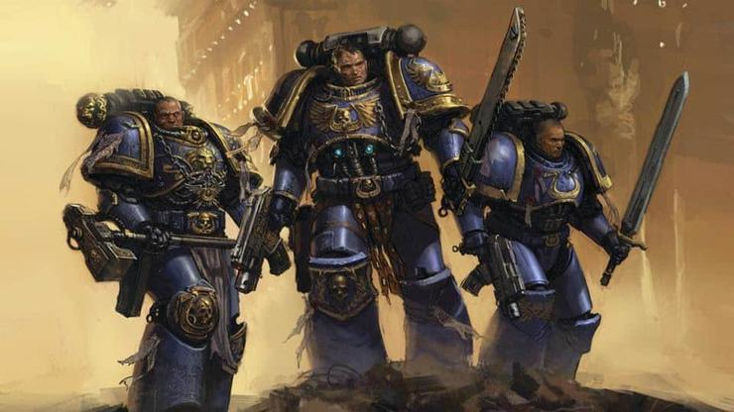
Prologue
5.6. M39 first flight upon the exploration of the warp. 10 space hulks have flown and 3 have lost contact. 1 has been lost off-course, but fortunately, 10 space trackers have been put on the ship, 3 are successful. Captain Mac has ensured safety upon those of the space marine’s 6th company, 1095656th department.

“What’s the status of the 4th space hulk, brother-lieutenant Lysander?” Questioned captain mac. He was a tall, broad, man with spots all over him. He was skinny, but bald. And he had a large scar down his face (we are all clones)
“Perfect sir, perfect,” exclaimed Lieutenant Lysander, “They are perfect on fuel, power and supplies! If we tell the 5th space hulk captain to communicate and rescue the crew from the 2nd hulk!”
Yes, let’s do that then. Tell the techmarines in department 96jk to redirect the our secondary coms line to the 2nd space hulk”
“Yes sir!” Lysander walked to the on-board announcer. “Techmarines in department 96jk redirect the 2nd comms line the second space hulk”
As soon as he walked away there was an alert on the security panel. It flashed bright and it made a peculiar siren sound.
“What is it?!”Screamed Lieutenant Lysander.
“A security breech Lysander, a security breach” said captain mac, very calmly. Seconds after sparks flashed and the control panel blew up.

Chapter 1
6.6. M39

And this is where I come in. I was just a scout, no goal but to defend humanity, and avenge my lost battle brothers. This was not my first battle, but my 3rd. I had lost a close friend, Thomas. At a normal scout rate, you would lose 2 battle brothers a battle, but I was with the 2nd best sergeant, sergeant, coombes. He was a 50-year-old man who had survived 10 battles! His motto: a good soldier obeys without hesitation; a good commander orders without doubt. Amazing right? Anyway, that’s unupgh about people, let’s get on with the story. I WAS sitting in my “spiny-chair” (an office chair). My door opened. “Ah, battle brother luca, nice to see you!” he exclaimed.
“The pleasure is mine. I was just about to come and see you, as I have done all the research, training and, eating.”
“Really now? “He questioned.
“Yes,” I said, squinting my eyes, “yes it is.”
“Okay, just be at the lunch hall at 1900 hours.” He commanded.
“Yes sir!” when he was about to walk out the door, I saluted. As is tradition, he did it in return. He then walked out the door, without looking back.
I looked at my clock. “4 hours to sleep… “I sighed, but in a relaxed way. So, I clambered onto my triple-bunkbed, set my alarm clock for 4hours, pulled up my cover, and slept.

Chapter 2
6.6. M39
Explosions. Death. Screaming and blood. Emptiness. one last shot. Missed. felt like a deer just ran into me. More blood. Organs. Emptiness. I lay there, dyeing, and then nothing. Silence. Motionless. Pitch black. I hear again, this time someone shouts in my name. They’re shaking me, violently, ow! They punched me but I’m dead! Or am I? Light! I see my battle-brother Austin. “I… am I alive?”
“Yes, you are. You are, were, sleeping. You… I think you thought you died.”
“How did you know” I asked him, unsure that this is a dream or I’m in heaven.
“Because,” he said, with a big pause, whilst rolling his eyes,” you said when I woke you up, am I alive? , remember?”
“Oh, oh yeah.” I sat up, still unsure. “I’m going to see an apothecary.” I started to clamber down, trying to make sure I’m actually alive, or not sleeping or… dead.
“Aren’t you going to go see the chaplain?”
“No! I don’t really want him telling me that I’m going to go to war and… that will happen.” I refused, getting on my power armour.
“Then I’m going to have to get some sevitors to come and… collect you” he threatened, but not in a very threatening way.
“come on man,” I pleaded,” ya’ don’t have to do this, man!”
“Oh, but I do. I have to ensure safety upon the ultramarines.” He commanded, walking closer and closer.
“Fine!” I replied, pushing him away from me. “I’ll go, but I’m going to the apothecary first. You know what could happen with nightmares that aren’t treated and are as bad as mime.” I glared at him.
“Poor ed,” he sobbed, unaware of me leaving, “he was so innocent.”
“yeah, he only died-,” I paused, thought about his death, relationship with Austin, what Austin was doing, then carried on talking. “-passed because he was-n’t the strongest or bravest soldier. He skipped all his training. He was death=bound.”
“No he wasn’t! he had done loads of training-,” I continued his sentence,”-to get into the space marines. That training. The first requirement. He had to do a lot more training.”

KABOOOOOOOOOOOOOOOOOOOOOOOOOOOOOOOOOOOOOOOOOOOOOOOOOOOOOOOOOOOOOOOOOOOOOOOOOOOOOOOOOOOOOOOOOOOOOOOOOOOOOOOOOOOOOOOOOOOOOOOOOOOOOOM!!!!!!!!!!!!!!!!!!!!!!!!!!!!!!!!!!!!!!!!!!!!!!!!!!!!!!!!!!!!!!!!!!!!!!!!!!!!!!!!!!!!!!!!!!!!!!!!!!!!!!!!!!!!!!!!!!!!!!!!!!!!!!!

END OF NOVEL 1
TO BE CONTINUED IN NOVEL 2

CREDITS:
Luca Wilkinson: author
Random people(s): illustrator.
Everyone in Microsoft: this program

