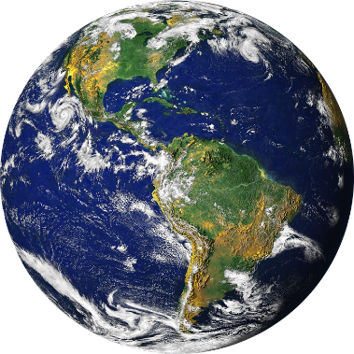

**What is Renewable Energy?**

**Renewable Energy is energy that is not harmful to the environment and will never run out.**

**SAVE OUR PLANET!**

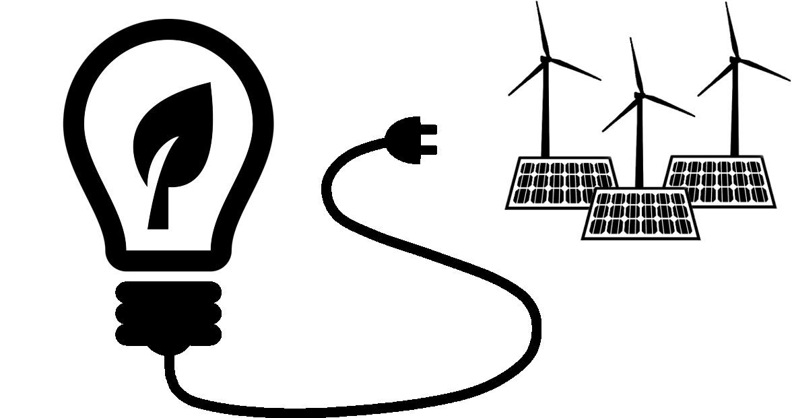

**By Stella Chapman**

**RENEWABLE AND NON-RENEWABLE ENERGY**

**What is Non-Renewable Energy?**

**Non-Renewable Energy is energy that is harmful to the environment and will run out one day.**

**We need to use Renewable Energy such as wind turbines, solar panels and geothermal power to save our planet!**