HOW TO MAKE YOUR OWN
CHICKEN NUGGETS
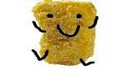
With Oscar Hill. (Who loves chicken nuggets.)

You will need:
Half a cup of flour (64 grams)
One beaten egg (mash with a utensil or whisk)
One pound of chicken breast
3 teaspoons of seasoned salt
Half a cup breadcrumbs (can be either Italian or Panko)
3 teaspoons of pepper
You can have: one eighth of parmesan cheese in a cup
You can have: one quarter of garlic powder.
Separate the flour egg and oil into different jugs or cups.

Note: you don’t need the cheese or garlic, they are just for option if you want to make these chicken nuggets.

STEP ONE
As carefully as you can, cut or trim off the fat from the chicken breasts, and cut them into approximate chicken nuggets sized (and shaped) nuggets. And if you have a special preference, you can even turn them into tenders.
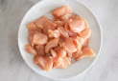

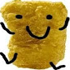

STEP TWO
Coat your chicken in some of the flour. Shake off any excess flour stuck to the chicken.
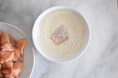

STEP THREE
Dip your chicken nugget into the beaten egg and make sure to cover both sides completely. If your fingers got hit by the egg, wash them before continuing.
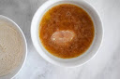

STEP FOUR
Now it’s time to cover the nuggets with the breadcrumbs. Again, make sure you coat both sides completely. And don’t worry about shaking excess breadcrumbs off.
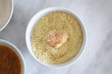

STEP FIVE
Carefully, place the nuggets on a cooling rack on a clean baking tray. If you are to bake your chicken, spray them with cooking spray.
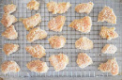

STEP SIX
In the oven, bake the nuggets for 25 minutes. Half way through the cooking, flip them over.
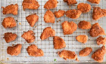

STEP SEVEN
Serve your chicken nuggets with any sauce you desire. Defeat the plain foods! >:)

