

Starting School
William Penn School
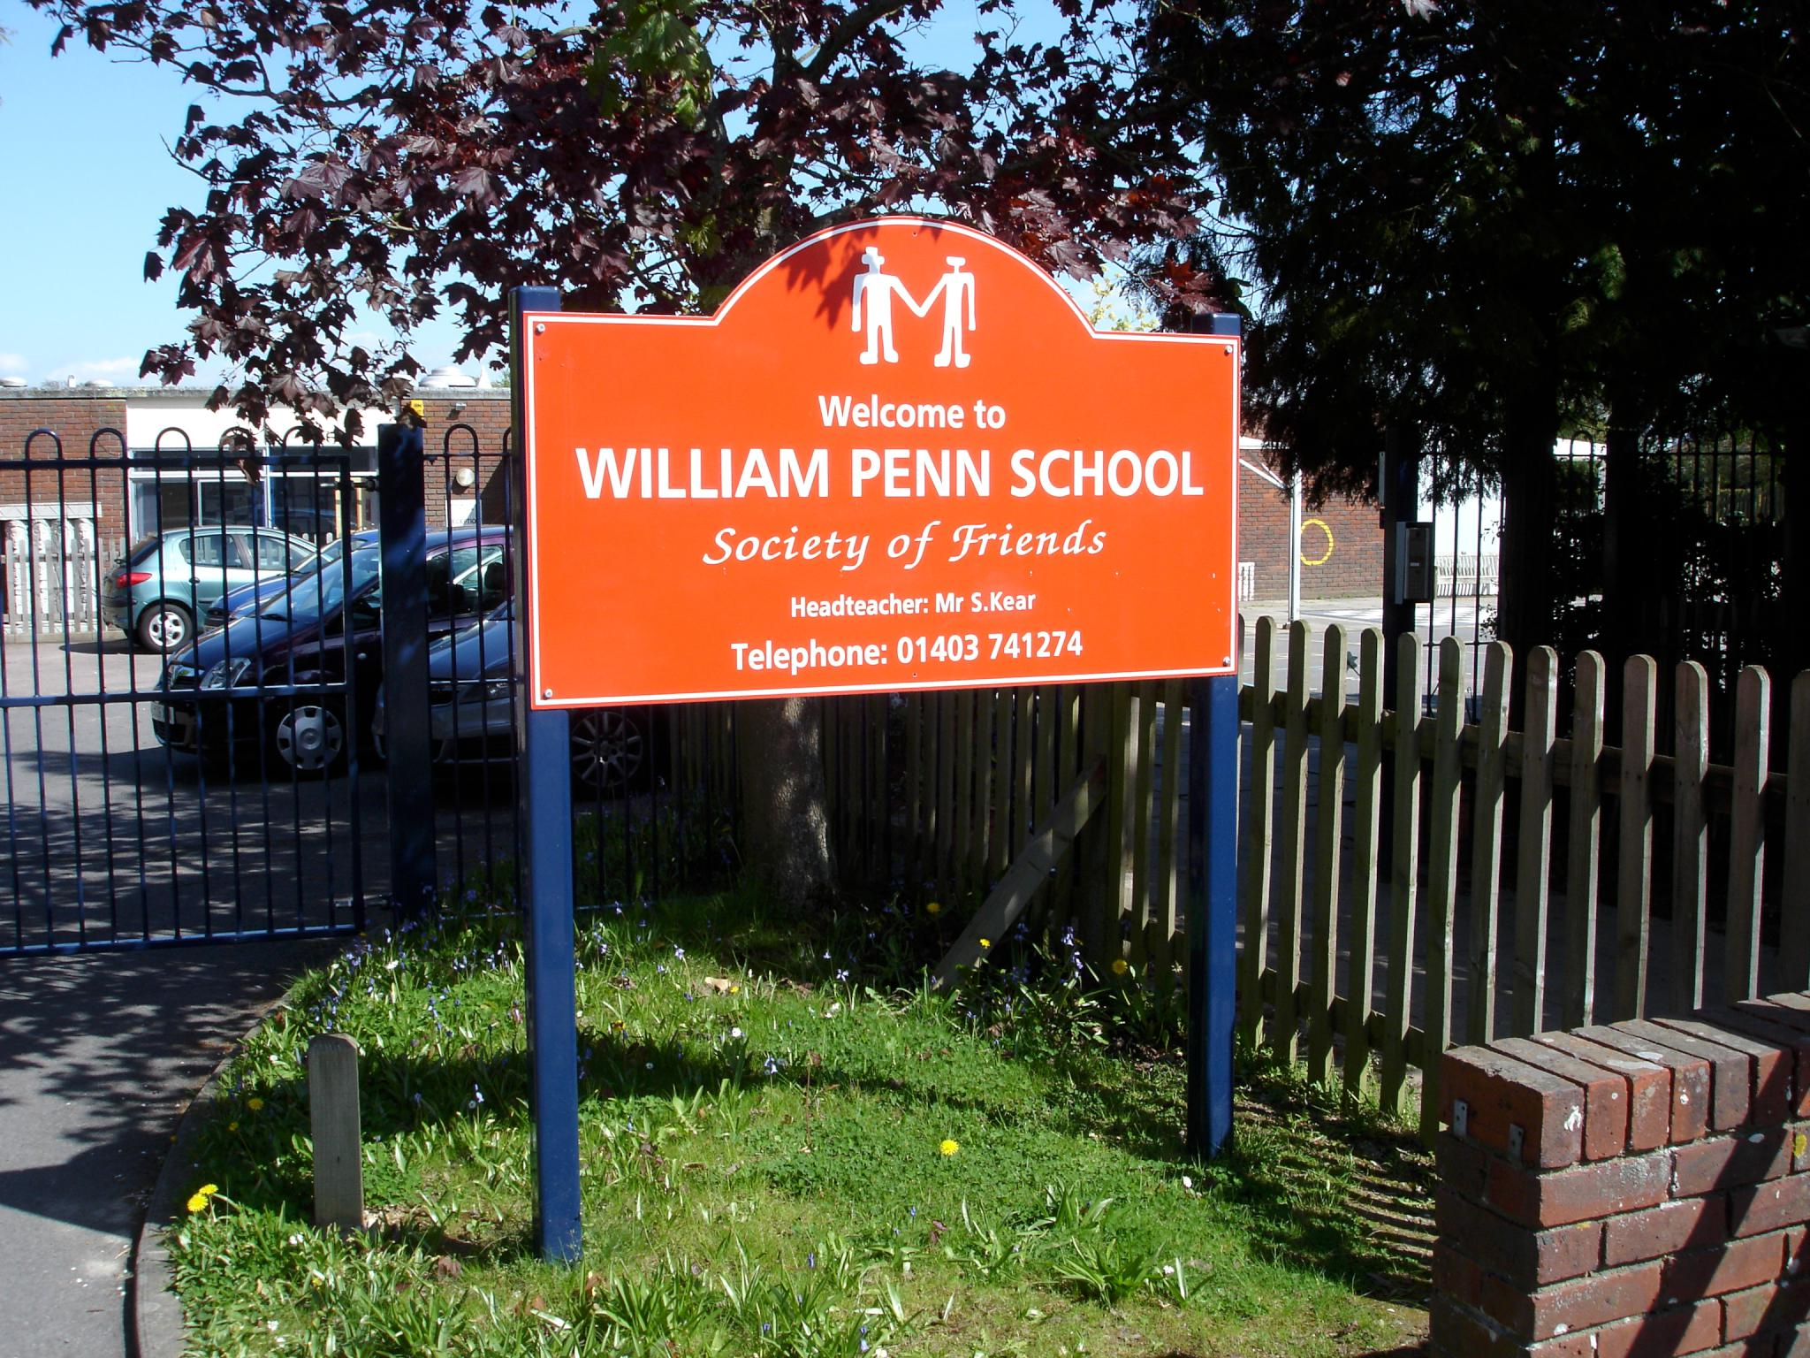
‘Living, Laughing and Learning Together’

We welcome visitors to the school.
Please contact us for an appointment on 01403 741274
Email: office@williampenn.co.uk
or
Join us on an Open Day (see calendar on website for details)

www.williampenn.co.uk

William Penn School

William Penn School is the only primary school in the country with a Quaker Foundation. It has been on its present site since 1973 and provides a high quality and nurturing start to the education of pupils in a rural, village community in Coolham, West Sussex. The school values are honesty, integrity, equality, peace, reflection and friendship.
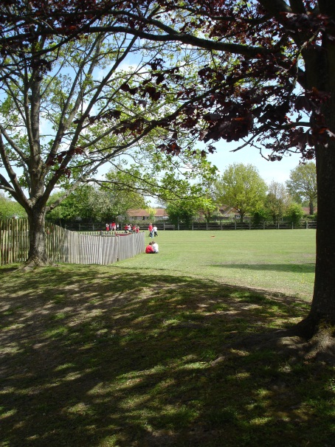
William Penn
Mission Statement

At William Penn, we believe that every member of the school community is a ‘teacher’ and a ‘learner’. We respect each other and value the rights and responsibilities of each individual. We are a school with a Quaker foundation, characterised by a caring ethos which places importance on honesty, integrity, reflection, equality, peace, friendship and simplicity. We strive for high standards and challenge ourselves to further our own learning and understanding throughout the journey of life.

We learn best when……………..

- We feel happy, safe, valued and respected
- We belong to a whole school community that works and plays together
- We have a stimulating and supportive learning environment which promotes independence and a safe and healthy lifestyle
- Careful planning provides relevant, memorable and exciting learning opportunities which challenge and motivate
- A range of teaching strategies meet our learning styles and needs
- We are active and there are opportunities for challenge, innovation and adventure
- We understand how to learn and are able to evaluate our progress and our success

Starting School

Starting school is an exciting time! It is another of the steps in your child’s life-long journey. You might be feeling a little apprehensive about your child’s first few days at school. However, the following suggestions will enable you to prepare and help your child settle down and enjoy this new adventure.

General Suggestions that Help You to Prepare

- Talk positively with your child about starting school

- Discuss your own positive memories of school with your child. Ask what they expect when starting school.

- Try to promote self-confidence in your child by using praise and encouragement to make them feel good about themselves.

- Encourage your child to be as independent as possible through daily routines such as:
- getting dressed/undressed
- cleaning teeth
- tidying up
- putting on/taking off shoes/coats
- go to the toilet and wash hands afterwards
- use a knife and fork
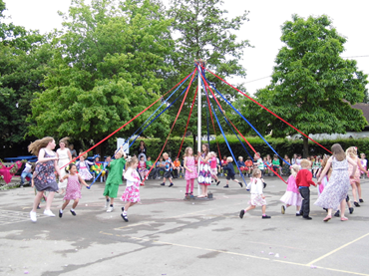
- blow their own nose
- sit cross legged on the carpet

- Encourage your child to take care of and respect their own things and the belongings of others.

- Give your child experience in taking turns and sharing.

- Enjoy art and craft activities such as:
- using scissors
- threading beads on a string
- tracing pictures
- using a pencil with confidence
- colouring in pictures
- drawing pictures of each other
- knowing the names of colours

- Play games:
- jump
- play board games
- build towers of bricks
- catch a ball thrown gently
- run with awareness of space

- Take every opportunity to talk with your child and encourage them to join in with conversation.

- Try to take time to answer your child’s questions and encourage their curiosity.

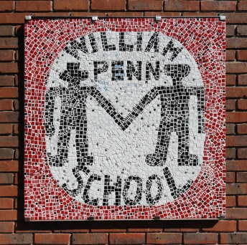
- Encourage your child to listen carefully to instructions, stories descriptions and explanations.

- Have fun with your child using action rhymes, finger rhymes and nursery rhymes.

- Help your child to recognise their written name and have a go at copying it.

Please visit us at:
William Penn School
Brooks Green Road
Coolham, Horsham, West Sussex
RH13 8GR
01403741274
Email: office@williampenn.co.uk

