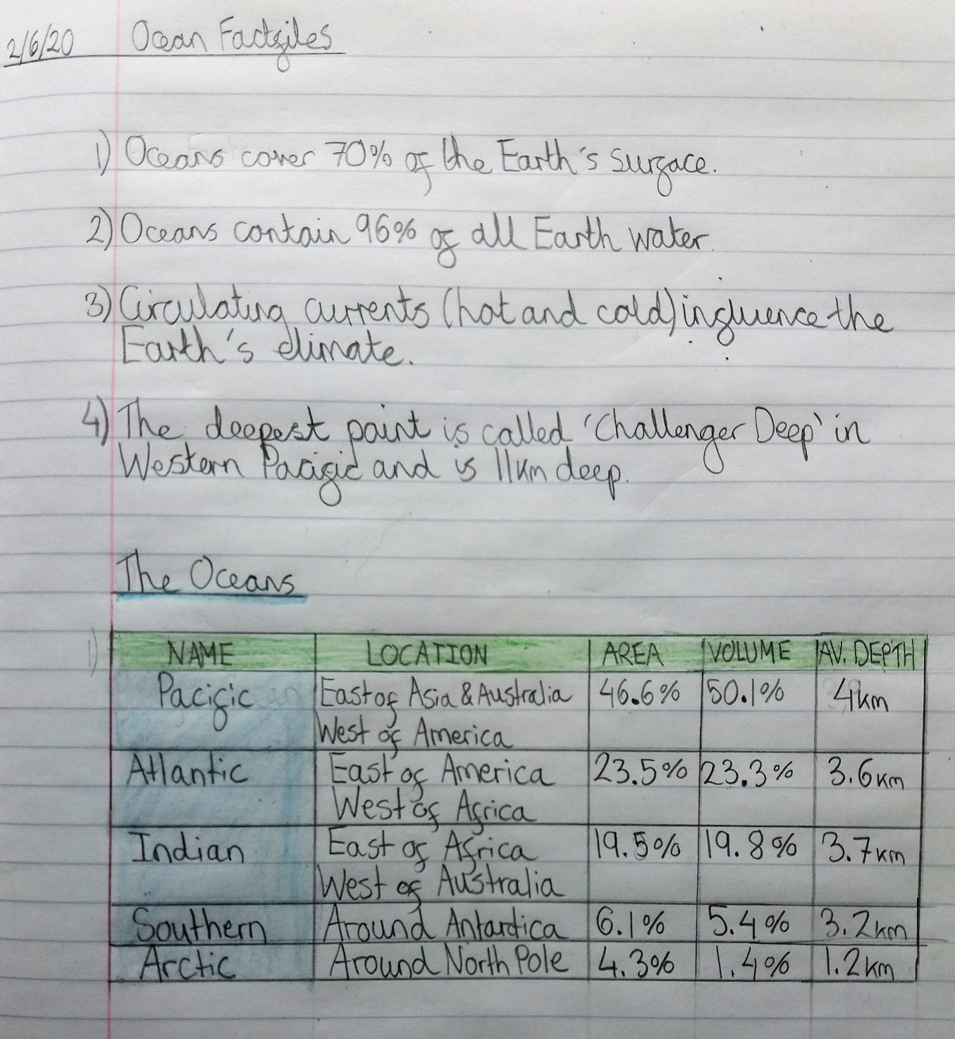

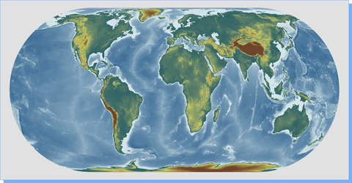

ARCTIC

PACIFIC

INDIAN

SOUTHERN

ATLANTIC